DTIL Project Report
Project title: Health Monitoring and muscle stimulation system (PulseGuard)
Listening of content:
sr.no | Section | Subsection
1. | Introduction | - Why You Chose This Project  - Background  - Theory of Design Thinking  - Literature Review
2. | Problem Statement | A clear and concise statement defining the problem your project addresses and its relevance.
3. | Goal and Objectives | 1.Goal- State the main purpose or vision for the project.  2.Objective- List specific, measurable objectives that outline steps to achieve the project goal.
4. | Summary of Secondary Research- Research papers | A concise review of research findings relevant to the project
5. | Summary of Primary Research- user interviews | Summarize insights gained from surveys, interviews, or observations.
6. | Analysis | Part 1: Analyse the findings from primary and secondary research.  Part 2: Develop inferences leading to recommendations for design.
7. | Redefining the Problem Statement | Refine the original problem statement based on research and analysis.
8. | Ideation | - Brainstorming  - Mind mapping  - Affinity Mapping  - 5W1H  - SCAMPER Tool  - Three Laws of Design Thinking
9. | Prototyping | Soft Prototype  Hard Prototype  Include visuals or diagrams of each prototype stage.
10. | Usability Studies/User Feedback | Summarize findings from usability testing and user feedback.
11. | Final Design Concept | Present the refined design concept with visuals or descriptions of the final product.
12. | Business Model | Outline a basic business model, including target audience and potential revenue streams.
13 | Future Directions/Steps | Suggest potential improvements or next steps for the project.
14 | Full References | Provide a properly formatted list of sources and research references
15 | Acknowledgments | Acknowledge any individuals or organizations who supported the project.

- Team Members :-
- Pranav Gaikwad
- Prathamesh Pagar
- Bhagwan Kote
- Prajwal Kote
- Saish Kote
- Introduction :
The project aims to design and develop a wearable IOT based health care system for elderly individuals. As people age, poor blood circulation and limited mobility often lead to discomfort, muscle stiffness, and reduced activity. Our device uses ESP32 as the central controller and vibration motors as stimulators to improve blood flow and provide gentle muscle massage.
Why you choose this project?
One day my Grandmother having a serious muscle cramp in the knee part and she cannot able to walk like before.So, we go to the doctor and they say that she needs daily massage and care but in my family everyone is busy and I also have to go to college and no one their for her help so I have an idea to change this by using this technology I will help my Grandmother and take care of her. There are expensive medical massage equipment or recurring therapy appointments, this solution offers a one-time investment that provides long-term therapeutic benefits.
Background
The Growing Number of Older Adults There are more elderly people in the world than ever before. By 2030, about 1 in every 6 people will be 60 years old or older. That's a massive change, and it means we need better ways to help older people stay healthy without breaking the bank.Why Blood Circulation Gets worse as We age When people get older, their blood vessels get stiffer and their hearts don't pump as strongly. This means blood doesn't flow as well through the body, especially to places like hands, feet, and legs. This causes all kinds of problems feet get cold and swollen, legs cramp up, wounds take forever to heal, and people just feel tired all the time. Sitting or lying down for long periods (which older people often do) makes everything worse.
Theory of Design Thinking

Design thinking is a human-centered approach to innovation that emphasizes understanding user needs, challenging assumptions, and iterating solutions through prototyping and testing. This project employs the five-stage design thinking framework to develop an effective elderly care solution. Stage 1: Empathize-The first stage involves deeply understanding the elderly users and their caregivers.Through observational research and interviews, several key insights emerged.Stage 2: Define - Based on empathy research, the core problem was defined clearly: elderly individuals with circulatory problem. Stage 3: Ideate - The ideation phase explored multiple solution concepts, including wearable vibration belts with integrated motors, handheld massage. Stage 4: Prototype-The prototype development followed an iterative approach, beginning with low-fidelity prototypes using basic vibration motors.Stage 5: Test-User testing was conducted in multiple iterations with elderly participants and healthcare professionals.
Literature Review
We read different research papers and articles related to muscle stimulation and IoT healthcare.Some key takeaways:Vibration therapy helps increase blood flow and reduce pain. IoT integration allows users to control therapy remotely.Wearable devices improve comfort and user experience.ESP32 is widely used in low-cost healthcare IoT devices.Example sources:“IoT-Based Health Monitoring System Using ESP32,” IEEE Conference 2022.“Effect of Vibration Therapy on Muscle Stiffness,” Journal of Medical Science, 2021.
- Problem statement:
Elderly individuals often experience weak muscles and poor blood circulation, and existing treatment solutions are either bulky, costly, or inaccessible. There is a need for a compact, affordable wearable device that can effectively stimulate muscles and monitor vital signs, contributing to improved elderly care and aligning with SDG-3 (“Good Health and Well-being”) and SDG-9 (“Industry, Innovation, and Infrastructure”) by promoting innovative and resilient digital health solutions.
- Goal and Objectives:

Goal:

To design and develop a compact, affordable, and smart wearable device that helps elderly individuals improve muscle strength and blood circulation while continuously monitoring their vital signs for better health management.

Objectives:

- To create a lightweight and user-friendly wearable device suitable for elderly users.
- To implement muscle stimulation using vibration motors or similar actuators to enhance blood circulation.
- To integrate sensors for monitoring key vital signs such as heart rate, temperature, and movement.
- To establish wireless data transmission for real-time health tracking through a mobile application.
- To ensure cost-effectiveness and scalability, aligning with SDG-3 and SDG-9 for promoting health and technological innovation.
- Summary of Secondary Research- Research papers
The study “Effects of Electrical Muscle Stimulation on Core Muscle Activation” (2023) examined how adding electrical muscle stimulation (EMS) to regular strength training influences core muscle activity in healthy, non-athletic adults. The findings revealed that participants using EMS showed greater muscle activation and contraction compared to those performing exercise alone, with no reported adverse effects. This demonstrates that EMS is safe and effective for regular healthy individuals, not just for hospital patients or athletes. Although functional performance improvements were limited within the short study duration, the research validates EMS as a practical and safe method for enhancing muscle function—supporting its potential integration into compact, wearable devices aimed at improving muscle strength and circulation in the elderly.
Similarly, the “IoT-Based Healthcare-Monitoring System towards Improving Quality of Life” (2022) highlighted how IoT-enabled health systems can continuously monitor vital signs, detect early abnormalities, and reduce the need for frequent hospital visits. The study found that remote health monitoring helps cut healthcare costs while improving overall quality of life. It also discussed challenges such as data privacy, energy efficiency, and interoperability between devices. These findings reinforce the importance of IoT integration for effective and accessible healthcare solutions.
Together, these studies form a strong foundation for the proposed project: a low-cost, IoT-enabled wearable that combines muscle stimulation and vital-sign monitoring for elderly care. The first study confirms the safety and benefits of EMS, while the second establishes the value of IoT-based monitoring in improving health outcomes and affordability. Integrating both concepts supports Sustainable Development Goals SDG-3 (“Good Health and Well-being”) and SDG-9 (“Industry, Innovation, and Infrastructure”) by advancing innovative, affordable, and digital health technologies for an aging population.
- Summary of Primary Research- user interviews:
Interviewer 1 - Mr. Sopan Supekar, a 66-year-old who has experienced paralysis and needs daily massages for his recovery. During our talk, he shared that managing his health every day can be quite challenging. When I explained the idea of an IoT-enabled health monitoring system, he seemed really interested. Mr. Supekar mentioned that this would help him feel more independent and less worried about missing any important health signs. He also added that the device should be simple to use and give accurate results so that he can rely on it with confidence in his daily life.
Interviewer 2 -Mrs. Suman Shinde, a 60-year-old who has been dealing with arthritis for several years. She told me that joint pain and stiffness often make her daily activities difficult, especially in the mornings. She said that regular monitoring of her health and physical condition could really help her manage the pain better. She believes it could help her understand her condition better and adjust her routine accordingly. She also said the system should be easy to handle and comfortable to wear, as she prefers simple technology that doesn’t add extra effort to her day.
Interviewer 3 -Mrs. Surekha Gaikwad , a 61-year-old who requires daily massages due to age-related muscle pain and stiffness. She shared that her biggest challenge is the lack of availability of family members to help her regularly. Because of this, she often struggles to maintain her daily care routine. Mrs. Gaikwad mentioned that such a system could remind her about her massage or exercise schedule and send updates to her family members, even if they’re away. She feels that this would not only make her more independent but also give her loved ones peace of mind knowing she’s being monitored safely.
- Analysis:
Part 1 - Analyse the findings from primary and secondary research.
From our primary research with elderly people and caretakers, we found that many face problems like weak blood circulation, joint pain, and muscle stiffness. Most of them said they feel better after light massages or therapy, but they can’t do it regularly due to high cost or lack of help. Caretakers also mentioned that the elderly often forget to do their exercises. This showed us the need for an easy, automatic device that can provide muscle stimulation at home. Our secondary research showed that vibration and electrical stimulation improve blood flow and reduce pain. However, existing devices like TENS are costly and not suitable for regular home use. We also learned that the ESP32 microcontroller is good for IoT-based health devices because it supports Wi-Fi and Bluetooth.
By combining both findings, we understood that an IoT-enabled wearable device with vibration motors can be an affordable and simple solution for elderly muscle care.
Part 2 - Develop inferences leading to recommendations for design.
1. Develop Inferences This means you look at all the feedback and find common patterns, needs, and problems.
For example:
Users want simple and easy-to-use devices.
They prefer automated features like alerts, reminders, and tracking.
Accuracy and reliability are top priorities.
some users (like Mrs. Gaikwad) need remote monitoring because they don’t always have family around.
These inferences show what users expect or struggle with.
2. Recommendations for Design (What You’ll Do About It)
Next, based on your inferences, you suggest specific design ideas or improvements for your IoT device or system.
For example:
Add a simple touchscreen or voice interface for elderly users.
Include automatic health alerts that notify doctors or family members.
Design a lightweight wearable sensor for comfort.
Use large fonts and clear icons for easy visibility.
Add a reminder system for massages, exercises, or medication.

- Redefining the Problem Statement:
The initial problem statement focused on addressing the challenges faced by elderly individuals who experience weak muscles and poor blood circulation. It emphasized the need for a compact, affordable wearable device capable of stimulating muscles and monitoring vital signs to support better elderly care and promote innovation in healthcare technology.After conducting primary research and collecting user feedback, several additional insights were identified. Elderly users expressed the need for simplicity, reliability, and comfort in such devices. Many users, like Mr. Sopan Supekar and Mrs. Surekha Gaikwad, mentioned dependency on family members for daily health management, while Mrs. Suman Shinde highlighted the importance of ease of use due to limited familiarity with technology. Users also desired automatic alerts, reminders, and remote monitoring features to help them stay consistent with care routines.
- Ideation:
- Brainstorming
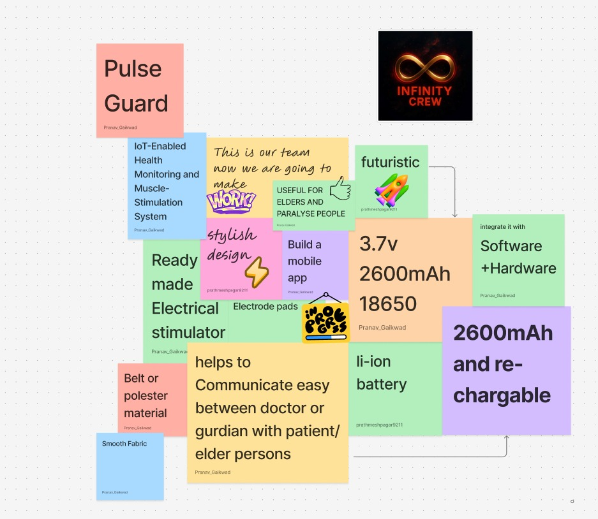
- Mind mapping:
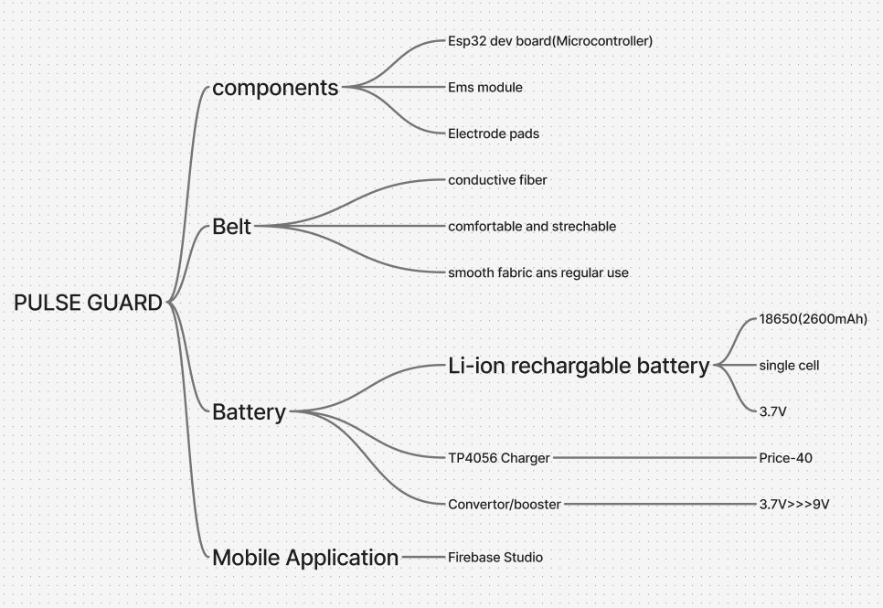
- Affinity mapping :
Wearable Hardware Architecture:-
  - ESP32 Dev – microcontroller
  - Vibrational motor – muscle stimulation
  - Rechargeable Li-ion battery – power supply
  - Belt - Around the knee
  - Belt Material: Elastic stretchable cloth
  - Electronics: Mounted in a small pouch
Mobile Application:-
- Key features:
- Real-time monitoring
- Hardware can be operated
- Alerts & notifications
- Scheduling & reminders
- Data visualization
- Chat/communication with doctors or caretakers
- Simple UI

5W1H Analysis – Muscle Stimulation and Health Monitoring System

Who
The proposed system primarily benefits elderly individuals who require regular health monitoring to maintain their well-being, as well as paralyzed patients who depend on consistent muscle stimulation for rehabilitation. Additionally, it assists gym users and athletes seeking faster muscle recovery and improved performance through regular stimulation and monitoring.

What
The main issue addressed is the lack of continuous, easy-to-use health monitoring and muscle therapy solutions. Many users face difficulty performing regular muscle stimulation exercises and often rely on manual therapy or infrequent clinic visits, which are less effective and time-consuming. This system aims to make health tracking and therapy more efficient and accessible.

When
The problem typically arises in home environments, where users spend most of their time and need constant health support. It is also relevant in gyms and rehabilitation centers, where real-time performance tracking and therapy are required. Moreover, it is crucial in remote or rural areas, where access to professional healthcare services is limited. Continuous monitoring becomes especially important during recovery phases, such as after surgeries or injuries.

Where
The system is designed for wearable, daily use, making it suitable for both home-based care and clinical environments. Its portability ensures effective health monitoring and muscle therapy regardless of location, supporting users in urban as well as rural settings.

Why
Solving this problem is essential to ensure early detection of health issues, which can prevent hospitalizations and severe conditions. Regular and controlled muscle stimulation helps improve muscle strength, reduce pain, and enhance rehabilitation outcomes. The system also promotes independence and a higher quality of life for elderly and physically challenged users by providing an easy-to-use and reliable therapy method.

How
The proposed solution uses an Electrical Muscle Stimulation (EMS) module controlled by an ESP32 microcontroller to deliver mild electrical impulses that cause muscle contractions. These contractions help strengthen and rehabilitate muscles over time. The system integrates with a mobile application for real-time monitoring, data visualization, and control, enabling users or caretakers to adjust stimulation levels, receive alerts, and schedule therapy sessions efficiently.
- SCAMPER Tool-
SCAMPER Element | Application in the Project
Substitute | Traditional physiotherapy and manual massage techniques are replaced with an automated wearable vibration-based stimulation system, ensuring continuous and consistent therapy without the need for manual effort.
Combine | Combines ESP32-based hardware with a mobile application to enable real-time monitoring, remote control, and communication between users, doctors, and caretakers.
Adapt | Adapts the concept of Electrical Muscle Stimulation (EMS) used in clinical rehabilitation and fitness devices to a daily-use wearable for elderly care and home-based therapy.
Modify | Modifies the device design into a compact, comfortable knee belt made of elastic, stretchable material, with electronic components enclosed in a small pouch for portability.
Put to Another Use | The device can be used not only for elderly users but also for paralyzed patients, gym users, and athletes to support muscle recovery, pain relief, and performance improvement.
Eliminate | Eliminates the dependency on frequent clinical visits and manual therapy, reducing time, cost, and effort while maintaining effective rehabilitation.
Reverse | Reverses the traditional approach of patients visiting heal

- Usability Studies/User Feedback:
From the user interviews and feedback collected, it was clear that there is strong interest and need for an IoT-enabled health monitoring system among elderly users with health challenges. Mr. Sopan Supekar (66), who experienced paralysis, emphasized the importance of accurate health tracking and real-time alerts to reduce dependency on others. Mrs. Suman Shinde (60), who suffers from arthritis, highlighted the need for comfort and ease of use, preferring a simple device that could monitor her activity levels and share updates with her doctor. Mrs. Surekha Gaikwad (61) expressed that such technology would be especially helpful for people like her who lack constant family support, as it could provide reminders and send health updates remotely. Overall, users found the concept useful, practical, and reassuring. The main suggestions included ensuring simplicity of design, accuracy of data, and automatic alerts or reminders for daily routines. This feedback suggests that the IoT-enabled system should prioritize ease of use, accessibility, and reliable connectivity to effectively support elderly individuals in managing their health independently.

- Acknowledgments:
- I would like to thank Sanjivani University for providing the platform and resources to carry out this project.
- I am deeply grateful to my project guide Mr. Kiran Wakchaure Sir for his valuable guidance, support, and encouragement throughout the research work.
- My sincere thanks to our HOD, Mrs. Devyani Bhamare, for her constant motivation and valuable suggestions.
- I would also like to express my appreciation to Mr. Sopan Supekar, Mrs. Suman Shinde, and Mrs. Surekha Gaikwad for their participation and honest feedback, which greatly contributed to the user research and design recommendations of this project.

